Creating Halqas In Your Local Majlis
What is a Halqa?
A Halqa (Neighborhood) is a smaller organizational unit under a majlis.
How does it operate?
Halqas operate in a similar manner to the local majlis in terms of communication and carrying out MKA duties. Monthly reports of their activities should be submitted to Qaid Majlis.
Just as members of the majlis must meet monthly, Halqas must meet once a month according to the MKA Constitution.
How is a Halqa managed?
The Halqa is headed by a Zaim (plural: Zoama). Zoama can have an Amila just as Qaideen would, with each secretary (Muntazim)* for the respective departments approved by the local Qaid Majlis.
Note: Saiqeen within each Halqa are part of the Zaim’s Amila.
*Mo’tamid department head will remain known as Mo’tamid
How is a Zaim elected?
Each Zaim is to be elected annually by the Khuddam within the respective Halqa. Elections can be held from the 10th of October up until the 10th of November. Qaid Majlis or a Qaid’s representative shall chair the election. Election forms are available at the end of this document.
Zoama elections must be submitted to Sadr Majlis for approval.
When should a Halqa be created?
In large majalis or majalis with membership great distances from each other, establishing Halqas is encouraged to keep members actively connected. However, creating halqas should only be done on a necessary basis. The ultimate priority is populating a local masjid/center if one exists.
How should the Halqa boundaries be determined?
Qaideen should consult with their Khuddam and take the following into account:
- Membership location & concentration
- Pattern of daily life and communal activities within the majlis
- Number of Khuddam in each Halqa*
- Natural barriers for establishing lines of boundaries (ex: roads, rivers, parks, etc.)
  - It is recommended to utilize this factor in regards to naming the Halqa
A review of the boundaries should be conducted yearly and any changes should be implemented by the 31st of October.
Note: Clear and legible Halqa Maps must be submitted along with election forms.
Sample Halqa Map of MKA Central Virginia
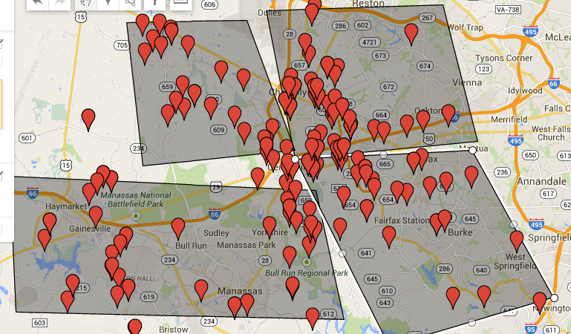

*Number of Khuddam should be approximately the same. However, exceptions can be made for majalis that are spread-out.

In the Name of Allah, the Most Gracious and Ever Merciful
Zaim Election Form
Majlis | Proposed Halqa Name | Tajneed | Attendance | Date | Presiding Officer

# | Proposed Name | Proposed By | Seconded By | Year of Birth | Total Votes
By signing this form, I declare that every eligible voter present casted his vote and the election was held in accordance with the rules and regulations governing the election of an office-bearer.
Name signed Office
Please attach a clear and legible Halqa map with the submission.

