Tuesday, September 23, 2014
Dear ______,
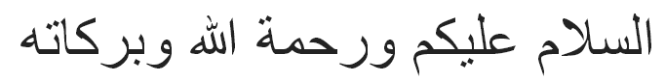
I pray these words reach you in good health and spirits.
As true servants of Khilafat, all members should strive to pay their auxiliary Chanda. It is essential that all Khuddam participate in the election of Qaid Khuddamul Ahmadiyya, which is one of the most important posts to serve the Majlis. We urge that you review your Khuddam and Jamaat Chanda, as no member who is more than 6 months delinquent of either Chanda will be eligible to vote upon election day.
According to our records, you hold a remaining balance of $____ in Khuddam Chanda.
Kindly bring your Chanda status up-to-date as needed by ____ (month) ___ (day), 2014, and please note that no Chanda will be accepted on the day of election.
Our local election of Qaid Khuddamul Ahmadiyya will be held on ___ (date) at ___ (time) at _____ (location). Kindly plan to be present at this election, as it is compulsory for every Khadim to participate.
May Allah enable us to be a true and sincere Khadim of the Khilafat of the time. Ameen.
Humbly requesting your prayers.

Khaksar
_______
Serving as Qaid ________, Majlis Khuddamul Ahmadiyya USA
qaid. @mkausa.org (###)###-####

